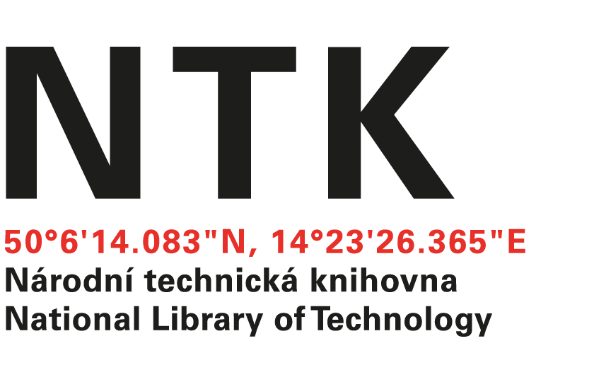
Letter of Acceptance

ERASMUS+
(Letter of Acceptance for Erasmus+ Staff Training Mobility
2016/17

We hereby confirm that the below mentioned person from Riga Technical University Scientific Library will be our visitor in March 2017.

Name and surname of the person:
Jolanta Ivanova
Name of host institution: The National Library of Technology (NTK)
Dates of start and end of mobility period /day/month/year/
from: / 6 / 03 / 2017 /
until: / 10 / 03 / 2017 /.
Number of working days: 4

responsible person at the host institution
NAME: POSITION: SIGNATURE:
Ing. Martin Svoboda Director
STAMP OF THE HOST INSTITUTION:

DATE:

